

**THE RACQUETBALL RACKET**

**OPIM 5641-BUSINESS DECISION MODELLING**

December 7, 2016

**Group 2**

Manaswini Rayappureddi

Pranav Sachdev

Ramya Chowdary Mupparaju

Venkatasai Varada

Contents

Executive Summary 2

Problem Description 3

Analysis 3

Base case Analysis 3

Effect of ball price on NPV 4

Competitor Analysis: 5

Combined effect of competitor and new plant Prices on NPV: 5

Effect of investment on NPV: 6

Findings and Managerial Insights 7

Conclusion 7

Appendix 8

# Executive Summary

Analyzing the past market trends, there’s no denying the fact that the racquetball industry has grown over the years. The industry has shown a steady growth rate and is expected to grow for the next 10 years. With high demand of the high-quality ball and a single market player, there’s a lot of untapped potential in the Racquetball industry. With a new manufacturing process to produce racquetball recently invented, which has reduced the cost of manufacturing the ball by almost 47%, the variable cost of a unit ball is expected to be as less as $0.52. The resulting high-quality ball has more bounce, but slightly less durability. However, it has also been observed that better players prefer a lively ball.

We were required to find if the manufacturing plant is a good investment. If so, we need to compute the price at which the new ball should be introduced to the market. Based on our analysis, it was observed that the ball should be introduced at **$1.25** to capture the maximum net profit. It’s also found that if the competitor maintains a status quo and keeps selling the ball at a price of $2.5/ball, the price of the new ball could lie anywhere between $0.63 and $2.42 for a positive net profit (with maximum net profit at $1.25).

We then tried to evaluate the effect of cost of manufacturing plant on the net profit (in 10 years) and found that if the plant is manufactured between $4 million to $6 million, we are expected to have net positive profits at the end of ten years. However, with the increase in the manufacturing cost of the plant between these two ranges, there’s a reduction in the net profit from $60 million to almost $56.5 million.

Suppose, the competitor is responding to the introduction of the new ball in the market. To cater to this scenario, we performed risk analysis. We considered that the worst case the competitor can price the ball is when it’s making zero profit, that is, selling at the cost price ($0.95). The best case is when it’s maintaining the status quo. It was found that with the variation of competitor’s price within this range, the net profit at the end of ten years would be $19 million.

Considering all the factors, the team concluded that investment into the manufacturing plant for the production of the new ball would be a favorable endeavor.

# Problem Description

A new and cheaper process has been invented for manufacturing racquetballs. The new ball is bouncier but less durable than the major brand. Unit variable costs of production for the new process is contrastingly inexpensive than the one manufactured using the current process. A new plant needs to be set-up which would cost between $4 million and $6 million. We have 14 years of data on the number of racquetball players in the United States, the average retail price of balls, and the number of balls sold indicates the market trend. The number of players is expected to increase at a steady rate for 10 years. 200 players were asked to use both balls over several months, and their preferences were assessed at several different prices for the new ball. The company wants to know if the investment in a new plant to manufacture balls using this new process is a good investment and if they can go ahead with it.

# Analysis

## Base case Analysis

The objective is to check if setting up a plant for new ball is a good investment. It is required to find the price of the new ball at which investment stands good and net present value of the plant is high. To find the net present value it is required to calculate Revenue, Profit and cash flow of the plant.

All the calculations are yearly based and total cost includes production cost and maintenance cost.

Annual amount paid to the bank is used for calculating cashflow. Equal annual payment method is considered for loan repayment.

The model maximizes net present value optimizing the price and price is constrained to 5.

**Fig: Profit over 2000 to 2009**

We observe that the profits increase over the years ranging from 2000 to 2009

The model results the optimal price for each ball to be $1.249 and the NPV accounts to be $59,951,700.59. Since the NPV turned out to positive it’s a good sign for the business.

Now that we found out the optimal price at which the ball is to sold and the NPV of the racquet ball plant. It’s time to understand the effect of various variables. Suppose, if one wants to change the price of racquet ball or the competitors in the market might come up with some new marketing strategies, to make sure that the racquet ball plant is prepared with all these effects we have performed the below analyses.

1. Effect of Ball price on NPV
2. Competitor price analysis
3. Variations in both new ball and competitors ball price
4. Variations in Investment

## Effect of ball price on NPV

It is not possible always to maintain a constant price. Price would be influenced by many factors such as Market Trends, Economic factors and Demand. To estimate the impact of change in balls’ price on NPV, we have considered price of the ball in the range of 0.52 to 5.

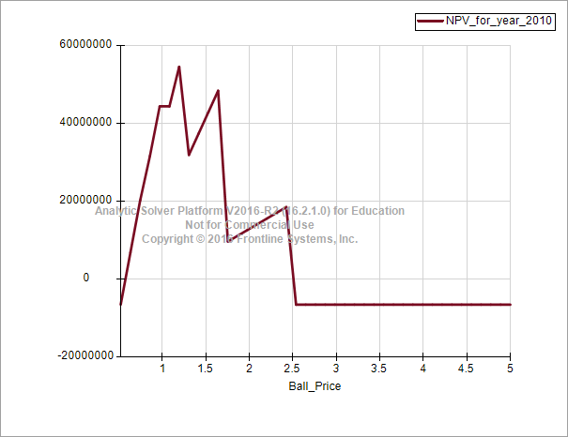

**Fig: Effect of Ball price NPV.**

NPV is less than zero for any price less than 0.6. The Maximum price at which the new ball should be priced is around 2.46 to be able to get a positive NPV.

## Competitor Analysis:

There is quite a good chance that when a new plant enters the market, the competitors would come up with some strategies to maintain market share. To estimate the impact of such strategies competitors price analysis is required. Considering a triangular distribution of variation is considered for competitor’s price.

With a minimum price of 0.95, most likely price of 2.5 and a max value 2.5, the triangular distribution of input gives the following distribution for NPV.

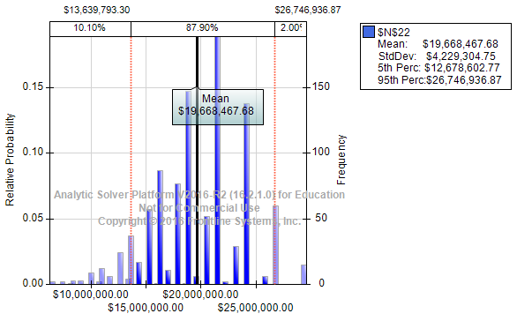

**Fig: Competitor analysis**

The mean value of NPV is $19,668,467.68. 5th percentile is $12,678,602.77 which says that, even if the competitor’s price varies in the above specified range, 95 % of the time the new plant would generate an NPV greater than $13,639,793.30 which is quite a good investment again. The new racquet ball plant is resistant to competitors’ price change in the specified range.

## Combined effect of competitor and new plant Prices on NPV:

So far, we have understood the effect of racquet ball price and competitors price individually, when a combined affect analysis is carried out the following were the results.

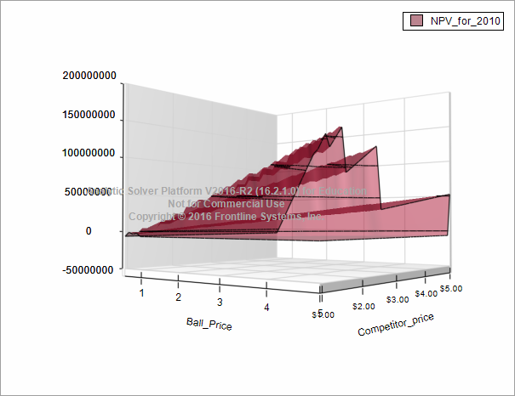

**Fig: variation of NPV with both competitor and ball price.** For any given competitor price, the NPV(profit) increases as our ball price increases until the optimized value of ball price, after the optimal value as the ball price increases, NPV decreases and becomes negative. also for any given ball price as the competitor price increases, NPV increases and as it decreases, NPV decreases.

## Effect of investment on NPV:

Since the management is planning to take a loan in between 4 million to 6 million, it is a critical decision to be made on the capital to be invested. Below is a chart that explains to make a decision on capital to be invested.The chart illustrates that when one increases the investment the NPV would follow a decreasing trend which can be attributed to reasons including high interest and annual pay to be repaid to the bank, high investment leading to high supply of balls for a given demand.

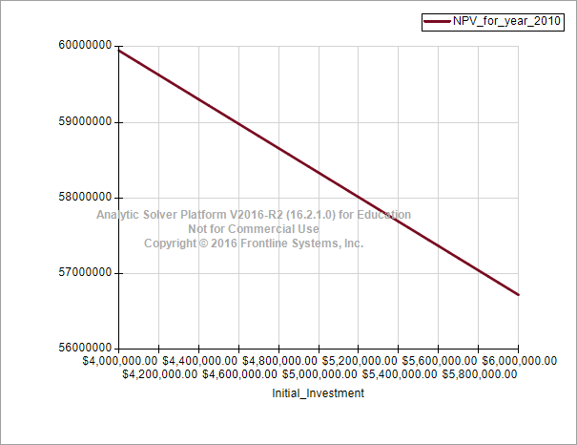

**Fig: Investment vs NPV**

The optimum value of investment is 4 million.

# Findings and Managerial Insights

1. Net Present value (NPV) at the ball price of 1.249 indicates that the investment in the new racquet ball plant is a profitable investment.
2. The new racquet ball plant should price their ball at a value greater than 0.6 else this wouldn’t be a good investment.
3. If the competitors don’t change their price, the new plant would preserve its market share and be able to produce a maximum NPV of $59,951,700.59, given the ball is priced at $1.249.
4. The ball should never be priced over $2.46. if so, this would directly affect the price ratio with a leading effect on the market share there by leading to a negative NPV.
5. Competitor’s price analysis gives us a strong evidence again that this investment is a good opportunity to enter into the racquet ball market. Though the competitor changes its price within a range of 0.95 and 3.2, there is 95 % chance that the NPV is over $12,678,602.77. The new plant is reluctant to competitor’s price change 95% of the time in the given range yielding NPV over $12,678,602.77.
6. When one increases the investment the NPV would follow a decreasing trend.

# Conclusion

From all the analysis we have made, we conclude and recommend to go ahead and invest in the new manufacturing plant. With a very high net present value, the plant has a great chance of being successful at an initial investment of 4 million. With an increasing profits year by year, the new plan would easily be able to clear the loan in a span of 10 years. On the whole, this plant once again proves innovation is the key for the success of a business along with a proper market research and pricing strategy

# 

# Appendix

a) Influence diagram

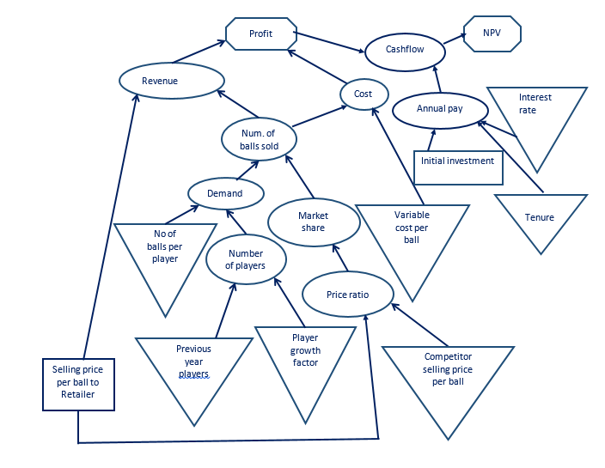

b) Problem Formulation

Parameters:

|  |  |
| --- | --- |
| Variable cost / ball | $0.52 |
| Variable cost for competitor’s ball | $0.95 |
| Initial investment cost | $4 million - $6 million |
| Interest rate | 10% |
| Selling price of competitor’s ball to retailer | $2.50 |
| Selling price of competitor’s ball (pack of 2) to end customer | $5 |
| % growth parameter in number of players | 10% for 10 years |

|  |  |
| --- | --- |
| **Price Ratio** | **% who would buy New ball** |
| 0.5 | 0 |
| 1 | 11 |
| 1.5 | 41 |
| 2 | 76 |
| 2.5 | 95 |
| 3 | 100 |

Where price ratio = price of Woodrow ball/price of new ball

|  |  |  |  |
| --- | --- | --- | --- |
| **Year** | **Number Players(Thousands)** | **Retail Price (per ball)** | **Balls Sold(millions)** |
| 1985 | 600 | $1.75 | 5.932 |
| 1986 | 635 | $1.75 | 6.229 |
| 1987 | 655 | $1.80 | 6.506 |
| 1988 | 700 | $1.90 | 6.82 |
| 1989 | 730 | $1.90 | 7.161 |
| 1990 | 762 | $1.90 | 7.895 |
| 1991 | 812 | $2.00 | 7.895 |
| 1992 | 831 | $2.20 | 8.224 |
| 1993 | 877 | $2.45 | 8.584 |
| 1994 | 931 | $2.45 | 9.026 |
| 1995 | 967 | $2.60 | 9.491 |
| 1996 | 1,020 | $2.55 | 9.996 |
| 1997 | 1,077 | $2.50 | 10.465 |
| 1998 | 1,139 | $2.50 | 10.981 |

Decision:

Selling price of new ball

Output measures /Objective:

1. Profit
2. Net Present Value(NPV)

Calculations

1. To calculate the number of players for 1999,2000

We calculate Rate of player Increment every year by using

Rate of player Increment=Number of players current year/Number of players previous year

Average player Increment rate= sum of All Year Player Increment rates/Total number of years

Rate of Increment in Number of balls sold = Number of balls sold current year/No of balls sold previous year

Average Balls sold Increment rate = sum of All year ball sold increment rates/Total number of years

Number of players in 1999= Number of players in 1998* Average player Increment rate

Number of players in 2000= Number of players in 1999* Average player Increment rate

1. Average balls purchased /player **=**Balls sold(million)/Number of players (1000)

Total Average balls purchased per player= sum of Average balls purchase for player for all years/total number of years.

1. Number of balls sold per year=Market share * Demand for that year/100
2. Demand=No of players*No of balls per player
3. Price Ratio = Competitors selling Price per ball / Selling Price per ball to retailer
4. Revenue=Number of balls sold*selling price per ball to retailer
5. Profit=Revenue -Total cost
6. Maintenance cost = Maintenance cost parameter * Investment
7. Total Cost=Production cost + Maintenance cost
8. Production cost= No of balls sold * variable cost per ball
9. Annual pay = (Initial Investment cost * Interest rate)/(1-(1+Interestrate)^Tenure)
10. Unpaid loan=principal – Annual pay
11. Principal=Annual pay- (Bank Interest rate*Initial Investment cost)
12. Cashflow = Profit-Annual pay
13. NPV = f(cash flow, Interest rate)

Assumptions

1.       Number of balls sold is equal to number of balls produced- In reality, the production will be according to market demand. So, the number of balls sold is equal to number of balls produced

2.       We are selling the balls only to retailers – The price for selling to only retailers is mentioned in the given data.

3.       Market share is a function of price Ratio and percentage of people buying based on given data – Price ratio depends on both competitor price and one’s own price. We have price ratio given as price of Woodrow ball/price of new ball.

4.       No third Competitor – Woodrow and new manufacturing company only exist in the market as per given data. / ball to retailer